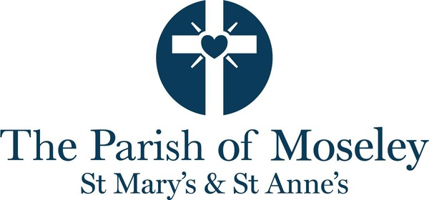

Parish of Moseley - Sixteenth Sunday after Trinity

Our Services for Sunday 20th September - Sixteenth Sunday after Trinity
- 8.00am - Holy Communion at St Mary's (BCP)
- 10.00am - Sung Eucharist at St Mary's
- 11.00am - Sung Eucharist at St Anne's
- 6.30pm - Evensong at St Mary's
Evensong is a traditional service where some of the liturgy is sung. The service is from the Book of Common Prayer (1662) with psalms, canticles, hymns, prayers, readings and a reflection.
Readings for the Sixteenth Sunday after Trinity: Jonah 3.10 – end of 4, Philippians 1.21–end, Matthew 20.1–16
Thought for the day by Michael Hell
Our readings this week contain a lot of grumbling: Jonah complaining about God predictably changing his mind, Paul reluctantly admitting that he was more use alive than dead, and the workers who had endured the heat of the day complaining that they were paid no more than the latecomers. Underlying this, however, is the thought that what matters most is the way we behave.
The Babylonians repented, and God did not impose the calamity he had in mind. Paul urges the Phillipians to “live their lives in a manner worthy of the gospel of Christ”: we are mostly fortunate that we have not been granted the privilege of suffering for it. The message of the parable of the labourers perhaps is that it is never too late to mend our ways, though this should not be taken as an invitation to follow Augustine of Hippo in praying: “Give me chastity and continence, but not yet.” We never know what tomorrow may bring.
---------------------------------------
Future Services
Sunday 27th September - Seventeenth Sunday after Trinity
- 8.00am - Holy Communion at St Mary's
- 8.30am - Breakfast Church at St Anne's Hall
- 10.00am - Sung Eucharist at St Mary's
- 11.00am - Sung Eucharist at St Anne's
- 6.30pm - Wholeness and Healing at St Mary's
Our service of Wholeness and Healing is a quiet service of readings, music, prayer and reflection, with a focus on wholeness and healing. You do not have to be unwell to come, and you will not need to share anything personal. There is an invitation to receive the laying on of hands with prayer; this may be for ourselves, for others, for a situation on our minds, or for the world. There is also the opportunity to be anointed with oil. Both are optional; you are simply invited to come as you are, bringing and sharing your burdens with God who knows us deeply.
Sunday 4th October - Harvest
- 8.00am - Holy Communion at St Mary's
- 10.00am - Sung Eucharist at St Mary's
- 11.00am - Sung Eucharist at St Anne's
- 6.30pm - Evensong at St Mary's
Evensong is a traditional service where some of the liturgy is sung. The service is from the Book of Common Prayer (1662) with psalms, canticles, hymns, prayers, readings and a reflection.
----------------------------------------
Our Regular Worship
- Details of our regular pattern of worship can be found on the Services page of our website here.
- Details of how the pattern relates to Children's Worship can be found on the Children and Youth page of our website here.
- Details of specific services can be found in the Calendar.
- Morning Prayer is at 9.00am in the Lady Chapel at St Mary's on Monday, Wednesday and Thursday and at 9.00am in St Anne's on Tuesday.
- Online Compline (Night Prayer) takes place at 7.30pm on a Wednesday. Please contact the office if you would like the Zoom link.
- The Thursday Midweek Communion service is at 12.15pm in the Lady Chapel at St Mary's.
- Our 10am Sunday service is usually livestreamed to our Parish YouTube page. The Parish YouTube page can be found here.
-----------------------------------------------
Notices - please continue to the bottom of the bulletin for events which are coming up
September Sermon Series
Sermons in September are focusing on our Parish Vision Statement, discussing its key pillars and what they mean for us. Each week will take a different piece of the statement:
- 6th September: A welcoming church
- 13th September: A church at the heart of Moseley
- 20th September: A church rooted in prayer
- 27th September: A church inspired by God's love
Heritage weekend
Special thanks to Robert and Angela Brown for organising last weekend's events at St Mary's for Birmingham Heritage week. The weekend's events were well attended and appreciated by those who came.
Inspiring videos shared by Birmingham Diocese during the Season of Creation
Throughout the Season of Creation (31st August to 4th October), there will be articles on the Church of England Birmingham website about caring for God's creation. Follow this link for more information.
Free Community Event in Moseley - 26 September
unWined is a Birmingham-based community initiative creating positive, inclusive social experiences where alcohol isn’t the focus. Their events are open to everyone, whether they drink alcohol or not – no labels and no pressure.
Their Autumn Social is a free, family-friendly event bringing together local independent food and drink producers, wellbeing activities and live music from local performers.
unWined Autumn Social at The Moseley Hive on Saturday 26 September, from 11am–3pm.
Harvest Collections for Sparkhill Foodbank
We will be collecting items for Sparkhill Foodbank during our Harvest services at both churches on 4th October. The Foodbank are in particular need of the following items - UHT milk, biscuits, tinned custard, tinned rice pudding, tinned fruit, tinned vegetables, cereals, tea, coffee, tinned fish, tinned meat, tinned tomatoes and instant mashed potatoes.
Christmas Fair
The kids have only just gone back to school and we’re already talking about Christmas!
St Mary’s Church Christmas Fair will be held on Saturday 28th November 10am - 2pm. Please put this date in your diaries. We’ll be raising money for our churches and chosen charities (The Busoga Trust, Practical Action and St Chad's Sanctuary).
We are busy planning all the usual festive fun, games and refreshments that make this event such a success but we are now in need of donations.
⭐ New this year! We will be holding a Christmas themed stall, instead of our usual bric a brac table, for all your festive bargains! We are now collecting donations so please bring in to church anything Christmas-related that we can sell. For example:
- Christmas decorations 🎄
- Christmas jumpers ⛄️
- Regiftable items (these must be brand new, unopened or in excellent condition) 🎁
- Christmas wrapping 🛍️🎀
We will not be accepting bric a brac so please do not bring it to the church.
🧸 Our popular Children’s Corner will return, so anything like unwanted toys, children’s books, games and jigsaws will be very welcome.
📚 We are accepting books for our Book Stall. Sorry we cannot take DVDs or CDs so please do not bring them to church.
🍾 We also need bottles for our Bottle Tombola.
Please ensure all donated items are in good working order.
Nearer the time we will be asking for volunteers to help out on the day, if you already fancy lending a hand please let the office know.
Thank you in advance for all your support, it is always appreciated. See you at the Christmas Fair!
Online Compline
Are you looking for a new challenge this autumn? Have you enjoyed coming to Compline over the summer? Would you like to try Compline (Night Prayer) but don't want to come out in the evenings? What is better than the opportunity to join our friendly online prayer group on Wednesday evenings at 7.30pm for just 20 minutes of prayer from the comfort of your own home. Do get in touch with the Parish Office for details of how to join if you would like to give it a try.
Prayer Corner
The Prayer Corner has been repositioned, returning to its original position underneath the Magnificat Window (almost diagonal to where it was by the Welcome Desk). Over the coming weeks we hope to develop this area a little. One change will be having a large bowl filled with sand, using small vertical candles to light, rather than using the small tea-lights which are difficult to recycle and often end up in landfill. We may also move to use a book where people can write prayer requests rather than pin post-it notes on a noticeboard. We also hope to introduce a prayer focus every 2-3 months with simple resources around a theme. Revd Magdalen.
Keeping safe in church
We are currently reviewing our lone working policy. If you come in to church on your own during the day, please do let the office know that you are there.
--------------------------------------------
This week in the Parish
We continue to pray for:
Sheila Perks, Trish Burt, Jane, Laurie Flood, Elizabeth, Ros Long, Christine Guest, Philip Mills, Christina Brown, Heather Smithson, Linda and Rosie Calloway, Bobby Bridgeman, Nick Adams, Ken Bonham, Sumit, Sam and Grace Macfie and Kevin Holland.
The Parish also prays and gives thanks for:
- Food producers especially those who are local, for Moseley Farmers Market and for those who run cafes and restaurants in the village.
- Everyone who lives in our parish - this week praying for all our neighbours who live on Birches Close.
Church of England Birmingham Praying Together: The September edition is here.
Inclusive Church Newsletter: The July edition is here.
We celebrate the Birthdays of: Fiona Lodge, Bethany Everett and Norman McLeod.

Future events
- SEP 26
Coffee Concert
Saturday, 26 September 11:00
11.00am: Saturday Morning Coffee Concert The Amanda Lipman Ensemble: L'estro Armonico Music by Vivaldi, Boccherini, Bruch, Schubert and Tchaikovsky Coffee, tea and toast available from 10.30am....

- SEP 27
Midland Chamber Orchestra Concert
Sunday, 27 September 13:30
Join the Midland Chamber Orchestra for a lunchtime concert featuring a variety of classical string orchestra music. Purcell - Excerpts from 'Abdelazer' Bach - Concerto for 2 violins Elgar - Serena...

- OCT 06
Tuesday Teas
Tuesday, 6 October 14:00
Tuesday Teas is a monthly group and you are warmly invited. There will be hot drinks, homemade cakes and the opportunity to chat. All are welcome - no need to book.
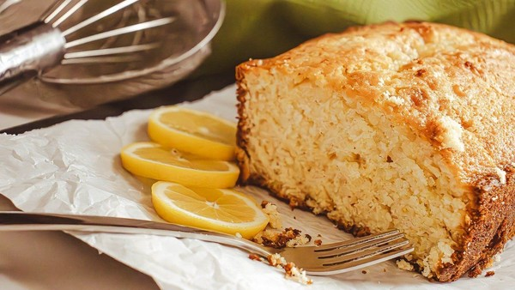
- OCT 07
Moseley at the Movies
Wednesday, 7 October 19:00
Come along to Moseley at the Movies, a group which meets to watch a film together and discuss afterwards. St Mary's West Room at 7pm.

- OCT 12
Eat Pray Love
Monday, 12 October 18:30
6.30pm-8.30pm, Monday 12th October at St Anne's Church. An opportunity for everyone to join with our friends from our Oversight Area for a bring-and-share supper and Iona style-worship. Sign up o...
