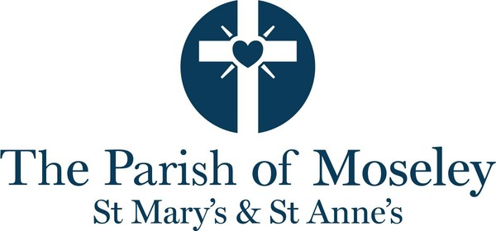
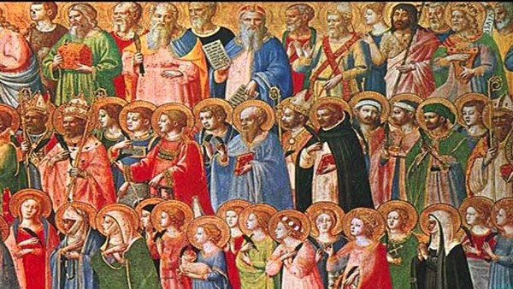
Parish of Moseley - All Saints and All Souls

Our Services for Sunday 1st November - All Saints and All Souls
- 8.00am - Holy Communion at St Mary's
- 10.00am - Sung Eucharist at St Mary's
- 11.00am - Sung Eucharist at St Anne's
- 5.00pm - Service of Remembrance, Thanksgiving and Hope at St Anne's
There is no 6.30pm service at St Mary's.
Parish breakfast will follow the 8.00am service
Extraordinary Parish Meeting (EPM) to elect Churchwarden after the 11am service at St Anne's.
Evensong is a traditional service where some of the liturgy is sung. The service is from the Book of Common Prayer (1662) with psalms, canticles, hymns, prayers, readings and a reflection.
Readings for All Saints and All Souls: Revelation 7.9–end 1 John 3.1–3 Matthew 5.1–12
Thought for the day by Mark Simons
On first reading of the Beatitudes with modern eyes, it is a puzzling piece of teaching! The challenge for us is to explore for ourselves the meaning and themes present.
Each of the Beatitudes consists of two phrases: the condition and the result.
The word ‘Blessed’ in the Greek is makarios, which can also mean Happy. This adds to the puzzling nature of this teaching, how can those who mourn be happy?
In this context happy is not the go-lucky, smiley, and cheerful happy, but rather a deeper happy or an enduring quality, where it is a blessing from God.
So, taking the Beatitude, ‘Blessed are those who mourn, for they will be comforted’, these words offer hope and comfort, that Jesus himself faced in his life and ministry with all the Beatitudes. We can take comfort that Jesus experienced and shaped who he was and how he lived; where ultimately there is a share in the Kingdom of Heaven for them especially.
This would have been surprising for the first listeners of this teaching. It was almost an upside-down way of thinking where there would have been familiarities in the Old Testament scripture with Moses teaching the people of Israel on the mountain following being given the Ten Commandments.
What could the Beatitudes look like today? I offer my own short Beatitudes.
Blessed are the unsure and uncertain;
for they are guided by your spirit.
Blessed are those who feel alone or isolated or rejected;
for the spirit is with them and God loves them.
Blessed are the addicts, the homeless and the beggar;
for God sees them and loves them.
Blessed are those who face the darkness daily;
for the light breaks through and glimmers in the shadows.
Blessed are those who are abused;
for they will soon see safety.
Blessed are for those ignored, unseen and forgotten;
for God knows them by name and loves them.
Blessed are those who don’t know what they feel at the moment;
for it is ok, it is ok, it is ok.
In this coming week, I offer a challenge of what would your beatitudes look like? It doesn’t have to be long, it doesn’t need to be perfect, but may it help shape your faith and day to day life, especially in the ups and downs of life.
---------------------------------------
Future Services
Sunday 8th November - Remembrance
- 8.00am - Holy Communion at St Mary's
- 10.00am - Sung Eucharist at St Mary's with Act of Remembrance
- 10.45am - Sung Eucharist at St Anne's with Act of Remembrance
- 6.30pm - A Service of Music and Readings for Remembrance Sunday at St Mary's
Please note that the service at St Anne's starts at the earlier time of 10.45am.
We welcome the Deputy Lord Lieutenant for the West Midlands to the 10.00am service at St Mary's.
Sunday 15th November - Second Sunday before Advent
- 8.00am - Holy Communion at St Mary's
- 10.00am - Sung Eucharist with Baptism at St Mary's
- 11.00am - Sung Eucharist at St Anne's
- 6.30pm - Evensong at St Mary's
----------------------------------------
Our Regular Worship
- Details of our regular pattern of worship can be found on the Services page of our website here.
- Details of how the pattern relates to Children's Worship can be found on the Children and Youth page of our website here.
- Details of specific services can be found in the Calendar.
- Morning Prayer is at 9.00am in the Lady Chapel at St Mary's on Monday, Wednesday and Thursday and at 9.00am in St Anne's on Tuesday. There is no Morning Prayer on Thursday 12th November.
- Online Compline (Night Prayer) takes place at 7.30pm on a Wednesday. Please contact the office if you would like the Zoom link.
- The Thursday Midweek Communion service is at 12.15pm in the Lady Chapel at St Mary's.
- Our 10am Sunday service is usually livestreamed to our Parish YouTube page. The Parish YouTube page can be found here.
-----------------------------------------------
Notices - please continue to the bottom of the bulletin for events which are coming up
Office Opening Hours
Please note that during weeks commencing 26th October and 2nd November, the Church Office will be open for reduced hours. If you need to come to the office, please call first to check we are here. Thank you.
Donations for St Chad's Sanctuary
St Chad’s Sanctuary is a local charity which offers a warm welcome and practical support to asylum seekers and refugees living in Birmingham. In past years, we have received substantial quantities of harvest food donations from churches and schools around the city. However, this year many churches are either running their own food banks or supporting their closest one (which makes perfect sense), so we've not had many donations. One of the things we're now running short of is supplies of tea, coffee and especially biscuits, which we like to serve to all those who come to us, including the students in our English classes. We would very much appreciate any donations of these items, which can be left in the box at the back of either church. Thank you! - Karen Gray (member of St Anne’s and ESOL Coordinator at St Chad’s Sanctuary)
All Souls Service - St Anne's 5.00pm, Sunday 1st November
If you would like the name of someone who has passed away to be read out at the service of Remembrance, Thanksgiving and Hope at St Anne's, please sign the sheet at the back of either church and we will add their name to the list.
Coffee concert and history tour this Saturday
The Saturday morning coffee concert at St Mary's at 11.00 am this Saturday, 31st October welcomes Mike and Elspeth Sullivan, keyboard and vocal duo showcasing light music classics, jazz standards and music to get feet tapping! Following the concert there will be a short free history tour of the church to learn more about St Mary's.
Churchwarden for St Anne's
As you may know, there has been no Churchwarden at St Anne's since Steve Alabaster and Danielle Edwards stood down last year. Trish Everett would now like to stand as Churchwarden, effective from January 2027. She will be elected at an Extraordinary Parish Meeting (EPM) after the 11am St Anne's service on Sunday 1st November. If you'd like to support her election, your presence at the 11am service and short election afterwards would be very welcome.
Feedback on chairs and pews
We have some additional samples of chairs and moveable pews to consider: please take a look and give us your feedback. You will find the samples and feedback sheets by the reordering display!
Knit a poppy for Remembrance
The knitting group meets on alternate Wednesdays at 2 pm. If you would like to join in contact Kate on 07853 244917.
If you would like to knit or crochet a poppy for Remembrance Sunday the instructions are here. If you are knitting poppies but don’t come to the knitting group, please bring your poppies into church asap so that we can create the display.
Autumn Well-Being Walk around Moseley Pool and Park
Saturday 14th November at 2pm.
We will be doing a contemplative walk around the Park together and then with some free time to enjoy the grounds. Tea and cake will follow at a cafe in Moseley. If very wet or windy we will postpone this event. Please meet outside the main entrance to the Park (down lane between Moseley Hive and Oxfam bookshop).
Faith, Menopause and the Meaning of MidLife - Saturday November 21st from 2pm-5.30pm
This event is one of a kind. Please come and support it!
Jayne Manfredi, author of Waking the Women and former colleague of Magdalen's will be speaking alongside Nasim Walji on how the experience of menopause and midlife deeply connects with our faith tradition. There will be time for sharing stories and a Q and A as well as refreshments. This is a multifaith event organised jointly by Moseley parish and Clifton Road mosque and is free of charge. However, please book here. The event is open to all women and men who hold a particular interest in this subject.
There will be a group of us leaving from Park Hill to walk down to the Transition Hall, Clifton Road, Balsall Heath on the afternoon if you are unsure where the event will be. If you have a question about this please speak to Revd Magdalen.
School Admissions 2027
If you are applying for a place for your child for September 2027 at Moseley C of E Primary School and require confirmation of church attendance, please contact the Church Office on 0121 449 2243 or office@moseleychurch.org.uk to book an appointment at our signing session.
The session will take place on Saturday 7th November from 10.30am - 12.00pm, in St Mary's Church. Coffee and tea will be available.
On the day of your appointment, please bring your completed school 'additional information for admissions form' (available on the school website) for Revd Angela or Revd Magdalen to sign.
Please note, it is not our practice to sign forms on a Sunday before or after church services when the priority of our clergy is worship and pastoral care of the congregation.

Advent Groups
This Advent we will be looking at Arun Arora's Advent book Stick with Love: Rejoicing in every tongue, tribe and nation. There will be 4 sessions on Wednesday evening at St Paul's Church, Mary Street from 7.30pm-9.0pm on the following evenings - 25th November, 2nd, 9th and 16th December. There will also be 4 sessions on Thursday mornings at St Mary's in the West Room on 26th November, 3rd, 10th and 17th of December from 10.00am until 11.30am. Those wanting to join the Meditation Taster sessions on 26th November and 10th December can leave the group just before 11.15am and join in the Lady Chapel.
Hot drinks, biscuits and cake served.
National Inter Faith Week 8th-15th Nov 2026
National Interfaith week is from 8th - 15th November. The programme of events is here.
Support the Community Fridge
The Community Fridge at Moseley Hive is running short of food. If you have any surplus fresh food, please consider donating it to the Fridge. For more information please check their website https://moseleycommunity.com/
Walking Bus for Trebles Practice
This term we are looking to trial a walking bus from Moseley C of E Primary School to St Mary’s Church for the Tuesday evening Treble practice.
A number of families have indicated that their child/ren would like to join the Trebles: however they are currently unable to make the logistics work. We are proposing that teams of two adults would collect children from school at 4.30pm and walk them to church in good time for practice which begins at 5.00pm. That 30 minute commitment is all that is needed as parents would collect their children at the end of practice at 6.00pm. If you would be willing to be a part of the walking bus rota for the trial period, we would be very appreciative, even if you could only sign up for one or two weeks. This role does require all adults to be DBS checked and to have completed Safeguarding training, both which the church can assist you with. Please let Rachel outreach@moseleychurch.org.uk or Mick music@moseleychurch.org.uk know if you are interested in helping.
Accessibility Aids
If you have additional needs and would appreciate using one of our resources, please let the Duty Warden or Sidesperson know. We have the following available on the Welcome Desk for you to borrow: Dyslexia Bibles, Dyslexia overlays for the orders of service and Ear Defenders.
Can you help with a welcome/support with Makaton/BSL
If you can use British Sign Language, and/or Makaton, and could help us during our services, could you let the Office know?
Receiving communion
If its easier for you to receive communion at your seat, please let the sidespeople/ deputy wardens know - they are the people you meet at the welcome desk.
Meditation Taster Sessions
If you are interested in experiencing a simpler and more contemplative kind of prayer we will be offering 2 taster sessions during Advent before the lunchtime communion service on Thursdays. These will be in the Lady Chapel from 11.15pm-11.45am on the following dates - 26th November and 10th December. No previous experience required. The basic format will be a few thoughts from the leader, explanation of a simple technique and then some silence. There will be time for a short discussion afterwards each time.
For those who can't make a Thursday we will be including some meditation at the Advent Quiet Morning on 12th December at St Anne's which will run from 9.30am-12.30pm.
Any questions please ask or email Revd Magdalen.
Christmas Fair
The kids have only just gone back to school and we’re already talking about Christmas!
St Mary’s Church Christmas Fair will be held on Saturday 28th November 10am - 2pm. Please put this date in your diaries. We’ll be raising money for our churches and chosen charities (The Busoga Trust, Practical Action and St Chad's Sanctuary).
We are busy planning all the usual festive fun, games and refreshments that make this event such a success but we are now in need of donations.
⭐ New this year! We will be holding a Christmas themed stall, instead of our usual bric a brac table, for all your festive bargains! We are now collecting donations so please bring in to church anything Christmas-related that we can sell. For example:
- Christmas decorations 🎄
- Christmas jumpers ⛄️
- Regiftable items (these must be brand new, unopened or in excellent condition) 🎁
- Christmas wrapping 🛍️🎀
We will not be accepting bric a brac so please do not bring it to the church.
🧸 Our popular Children’s Corner will return, so anything like unwanted toys, children’s books, games and jigsaws will be very welcome.
📚 We are accepting books for our Book Stall. Sorry we cannot take DVDs or CDs so please do not bring them to church.
🍾 We also need bottles for our Bottle Tombola.
Please ensure all donated items are in good working order.
Nearer the time we will be asking for volunteers to help out on the day, if you already fancy lending a hand please let the office know.
Thank you in advance for all your support, it is always appreciated. See you at the Christmas Fair!
Keeping safe in church
We are currently reviewing our lone working policy. If you come in to church on your own during the day, please do let the office know that you are there.
--------------------------------------------
This week in the Parish
We continue to pray for:
Sheila Perks, Trish Burt, Jane, Laurie Flood, Elizabeth, Ros Long, Christine Guest, Christina Brown, Heather Smithson, Linda and Rosie Calloway, Bobby Bridgeman, Nick Adams, Ken Bonham, Sumit, Sam and Grace Macfie, Kevin Holland and Peter Magson.
The Parish also prays and gives thanks for:
- Our team of Eucharistic Assistants and servers.
- Everyone who lives in our parish - this week praying for all our neighbours who live on Brockley Grove.
Church of England Birmingham Praying Together: The October edition is here.
Inclusive Church Newsletter: The September edition is here.
We celebrate the Birthdays of: Peter Jupe, William King, Matilda Thompson, Fiona Chew, Macie Groves and Kathy Freer

Future events
- OCT 31 Coffee Concert
Saturday, 31 October 11:00
11.00am: Saturday Morning Coffee Concert Michael and Elspeth Sullivan Light music, jazz and pop classics for keyboards and voice Coffee, tea and toast available from 10.30am. Admission free, r...

- NOV 03 Tuesday Teas
Tuesday, 3 November 14:00
Tuesday Teas is a monthly group and you are warmly invited. There will be hot drinks, homemade cakes and the opportunity to chat. All are welcome - no need to book.

- NOV 04 Moseley at the Movies
Wednesday, 4 November 19:00
Come along to Moseley at the Movies, a group which meets to watch a film together and discuss afterwards. St Mary's West Room at 7pm.

- NOV 14 Autumn Well-Being Walk around Moseley Pool and Park
Saturday, 14 November 14:00
Autumn Well-Being Walk around Moseley Pool and Park Saturday 14th November at 2pm. We will be doing a contemplative walk around the Park together and then with some free time to enjoy the grounds...
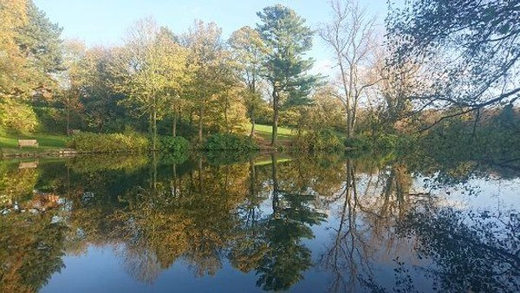
- NOV 21 Faith, Menopause and the Meaning of Midlife
Saturday, 21 November 14:00
Faith, Menopause and the Meaning of Mid-life Speakers: Jayne Manfredi (Author of Waking the Women) &amp; Nasim Walji Pirmohamed Saturday 21st November 2026 2-5pm followed by refreshments Transi...
